**Sinan DEMİRHAN 2016402330**

**IE 360 HOMEWORK 3**

**1)**





**2)**



**3)**

**a-)**

**res<-read.csv("UKPlasticPrices.csv",header = TRUE)**

**x<-ts(res$Price.Index,freq=12,start=1996)**

**library(forecast)**

**library(fpp2)**

**tsdisplay(x)**

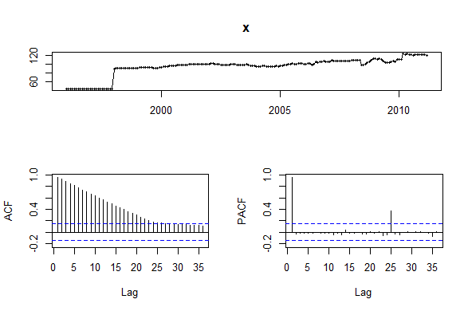

From the ACF plot it can easily seen that the data has a trend so we should take one level differencing to drop the trend.

**diffx<-diff(x)**

**acf(diffx)**

**pacf(diffx)**

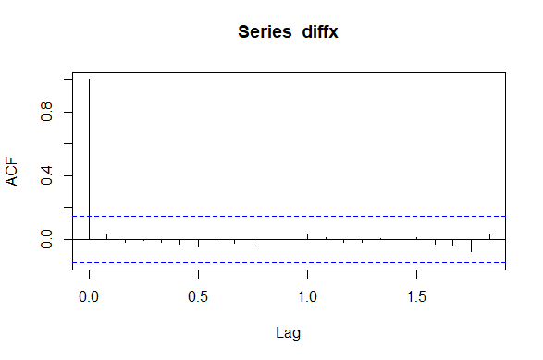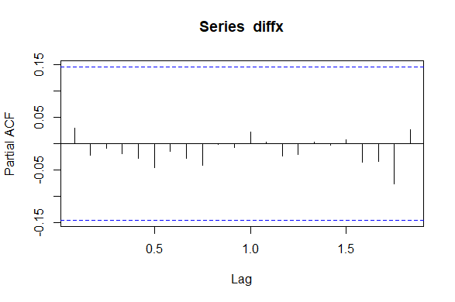

When we look at the ACF and PACF plots of the differenced data we can see that the trend disappeared.Also,the plots show that there is no dependency between lags so, using AR(0) and MA(0) will be useful for our Arima model.

**Arimax<-Arima(x,order = c(0,1,0),include.drift = TRUE)**

**Arimax**

ARIMA(0,1,0) with drift

Coefficients:

drift

0.4192

s.e. 0.2758

sigma^2 estimated as 13.92: log likelihood=-497.35

AIC=998.7 AICc=998.77 BIC=1005.11

**b-)**

**forecast12<-forecast(Arimax,level = c (95),h=12)**

**autoplot(forecast12)**

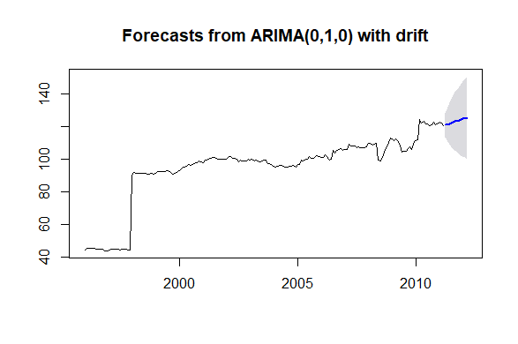

**forecast12**

Point Forecast Lo 95 Hi 95

Apr 2011 121.0192 113.7078 128.3306

May 2011 121.4385 111.0986 131.7784

Jun 2011 121.8577 109.1940 134.5214

Jul 2011 122.2769 107.6541 136.8997

Aug 2011 122.6962 106.3474 139.0450

Sep 2011 123.1154 105.2062 141.0246

Oct 2011 123.5346 104.1905 142.8788

Nov 2011 123.9538 103.2741 144.6336

Dec 2011 124.3731 102.4389 146.3073

Jan 2012 124.7923 101.6716 147.9130

Feb 2012 125.2115 100.9623 149.4607

Mar 2012 125.6308 100.3033 150.9582

**c-)**

When we look at the data it is seen that the extreme event in the time series data occur in the 24th month,so we omit the data until that point.

**newres<-data.frame.na()**

**newres<-res$Month[25:183]**

**newres<-data.frame(newres)**

**newres$Price.Index<-res$Price.Index[25:183]**

**newx<-ts(newres$Price.Index,start = 1998,freq=12)** #taking time series of our new data

**newx**

**tsdisplay(newx)**

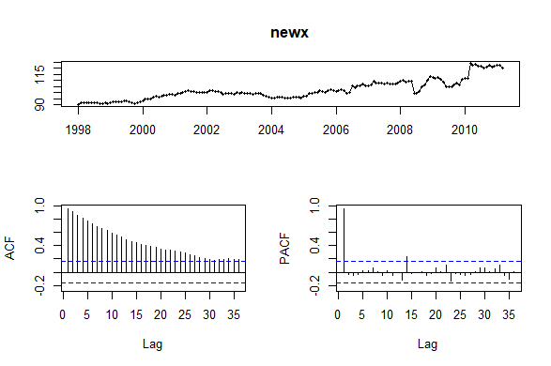

From the ACF plot it can easily seen that the data again has a trend ,so we should take one level differencing to drop the trend.

**diffnewx<-diff(newx)**

**acf(diffnewx,lag.max = 40)**

**pacf(diffnewx,lag.max = 40)**

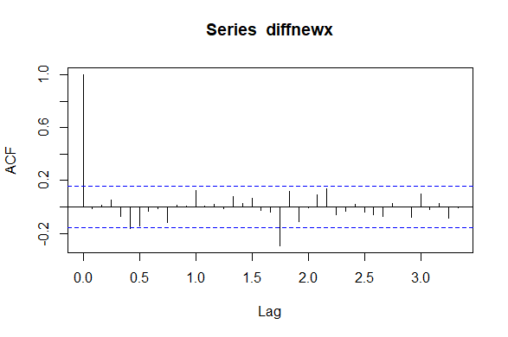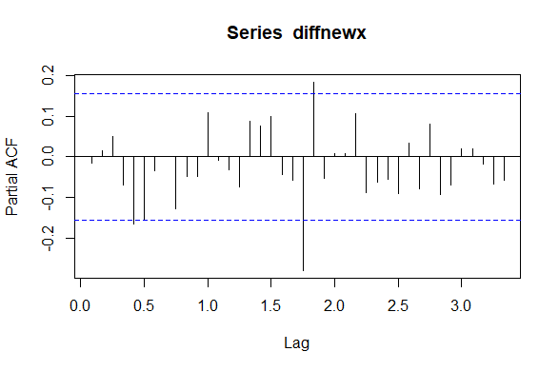

To use SAR(1) or SMA(1) is not understood by just looking these plots.In this situation to look at the AIC values of the 2 models will be much comprehensible.

**Arimanewx<-Arima(newx,order=c(0,1,0),seasonal = c(0,0,0),include.drift = TRUE)**

**ArimanewxwithAR<-Arima(newx,order=c(0,1,0),seasonal = c(1,0,0))**

**ArimanewxwithARdrift<-Arima(newx,order=c(0,1,0),seasonal = c(1,0,0),include.drift = TRUE)**

**ArimanewxwithMAdrift<-Arima(newx,order=c(0,1,0),seasonal = c(0,0,1),include.drift = TRUE)**

**ArimanewxwithMA<-Arima(newx,order=c(0,1,0),seasonal = c(0,0,1))**

**Arimanewx**

ARIMA(0,1,0) with drift

Coefficients:

drift

0.1962

s.e. 0.1400

sigma^2 estimated as 3.115: log likelihood=-313.46

AIC=630.92 AICc=631 BIC=637.04

**ArimanewxwithAR**

ARIMA(0,1,0)(1,0,0)[12] with drift

Coefficients:

sar1 drift

0.1233 0.1903

s.e. 0.0780 0.1567

sigma^2 estimated as 3.083: log likelihood=-312.22

AIC=630.45 AICc=630.6 BIC=639.63

**ArimanewxwithARdrift**

ARIMA(0,1,0)(1,0,0)[12] with drift

Coefficients:

sar1 drift

0.1233 0.1903

s.e. 0.0780 0.1567

sigma^2 estimated as 3.083: log likelihood=-312.22

AIC=630.45 AICc=630.6 BIC=639.63

**ArimanewxwithMAdrift**

ARIMA(0,1,0)(0,0,1)[12] with drift

Coefficients:

sma1 drift

0.1362 0.1895

s.e. 0.0851 0.1562

sigma^2 estimated as 3.079: log likelihood=-312.13

AIC=630.26 AICc=630.42 BIC=639.45

**ArimanewxwithMA**

ARIMA(0,1,0)(0,0,1)[12]

Coefficients:

sma1

0.1477

s.e. 0.0847

sigma^2 estimated as 3.086: log likelihood=-312.85

AIC=629.71 AICc=629.78 BIC=635.83

The differences in the AIC values among the models are very little but I take the SMA(1) as the best model with the lowest AIC value and make forecast according to that model.

**forecastnew12<-forecast(ArimanewxwithMA,level = c (95),h=12)**

**forecastnew12**

Point Forecast Lo 95 Hi 95

Apr 2011 120.3288 116.8855 123.7720

May 2011 120.5427 115.6732 125.4121

Jun 2011 120.3590 114.3951 126.3229

Jul 2011 120.3081 113.4216 127.1946

Aug 2011 120.1552 112.4558 127.8545

Sep 2011 120.2289 111.7947 128.6631

Oct 2011 120.4302 111.3202 129.5402

Nov 2011 120.2727 110.5337 130.0117

Dec 2011 120.2494 109.9197 130.5792

Jan 2012 120.3844 109.4959 131.2729

Feb 2012 120.2952 108.8753 131.7152

Mar 2012 119.7754 107.8476 131.7031

**plot(forecastnew12)**

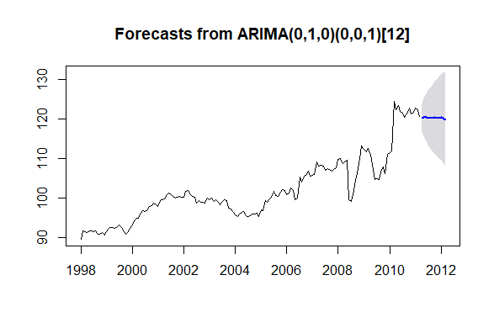

**Comparisons of two models**

When we used the full data we didn’t use any MA or AR terms and we made a forecast for 12 months and saw that the forecasts shows that there will be an increasing in the sales values within the next year. Hovewer,when we didn’t use the full data, the forecast by using SMA with 1 degree shows us that there will be decreasing in the sales within the next year.Also, there is a very important point which is that when we look at the confidence intervals of the forecasts, the interval ranges of two models differs from each other.The 95% confidence intervals of the model that is done by using the full data(x) are much higher than the model that is done by using the omitted data(newx)